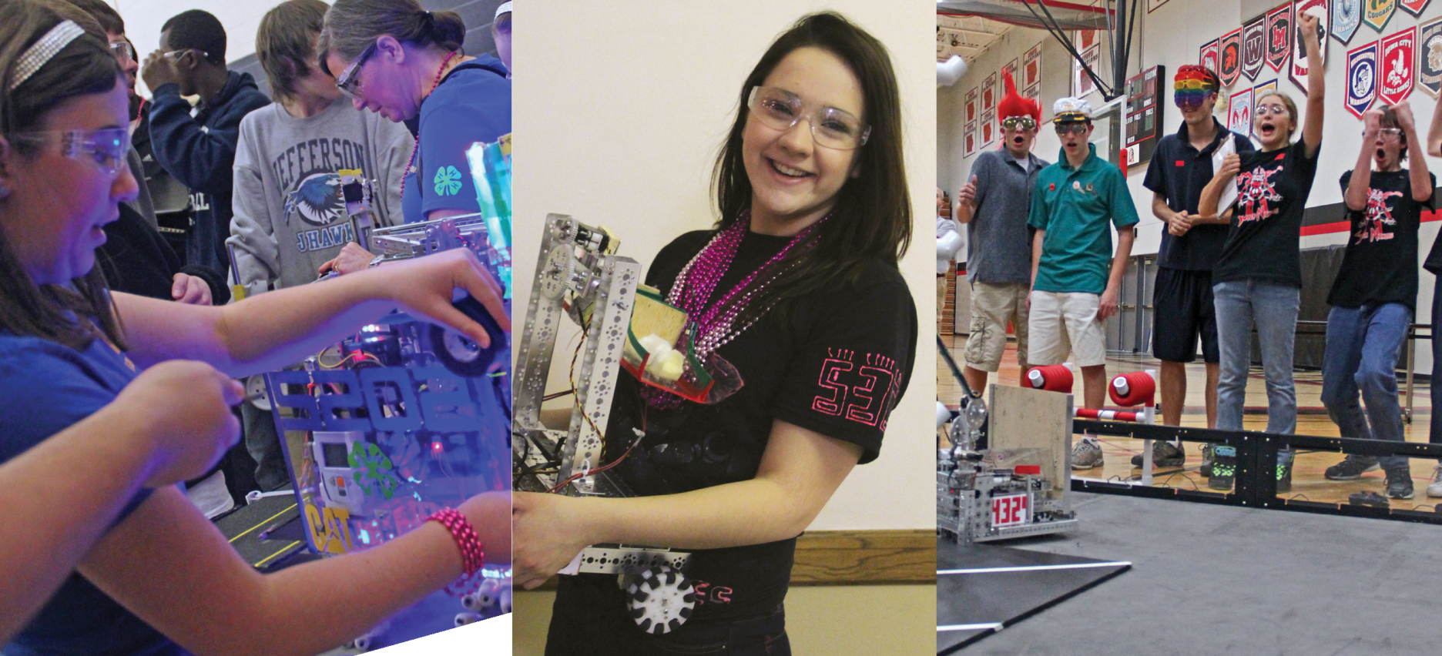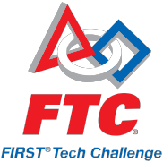

**Securing support**

How to build support to fund and promote your *FIRST®* Tech Challenge Team.

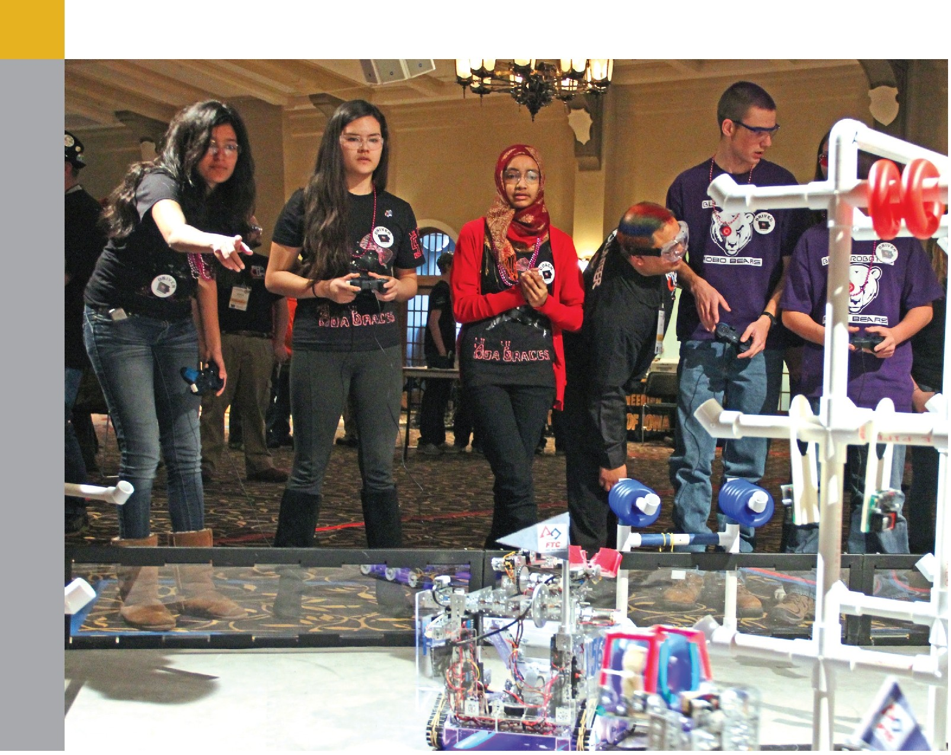

For more than eight years, *FIRST®* Tech Challenge (FTC®) supporters like you - Coaches, Alumni, Mentors, Parents, and other Volunteers - have been successful in spreading the word about the many benefits of getting youth and adults alike involved in the *FIRST®* experience.

They've told educators, administrators, parents, business owners, and other community leaders about the life-altering and game-changing social and educational experience *FIRST* is. And as a result, *FIRST* Tech Challenge has grown each year at a blistering pace.

To keep that momentum going, we need supporters to continue to be "ambassadors" for *FIRST* Tech Challenge in their communities.

While there are many ways to build buzz about the world of *FIRST* and its importance in our future, you and your team know the best approach for your community. That's why this guide was created. It was designed to provide guidance and direction on the best way to build support to fund and promote your *FIRST* Tech Challenge Team.

**Why seek community support?**

*FIRST* Tech Challenge teams are responsible for obtaining funds to sustain their teams. Most teams secure funding through a combination of grants, fundraising activities, and sponsorships/private donations. While many teams seek funding for just one year, long­term funding can ensure there's continuing support for your team.

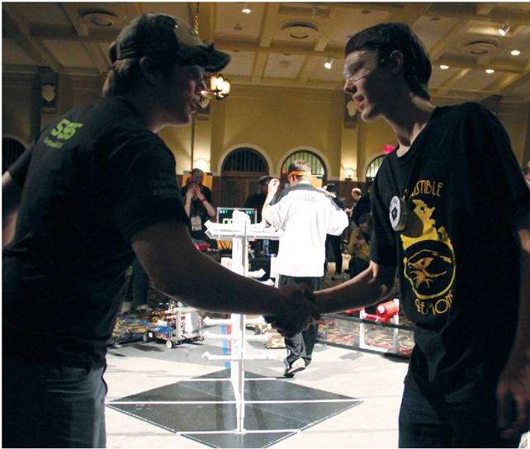**Grants**

*FIRST* Tech Challenge is supported by a strong network of businesses, foundations, educational and professional institutions, and individuals that provide grants and other levels of support. To learn more about grants available for FTC teams in your area, contact your local Affiliate Partner. Use the [Regional Contacts](http://www.usfirst.org/regional-contacts) tool to find their e-mail address.

**Sponsorships/private donations**

Local businesses and other organizations in your community often want to sponsor your team because:

* FTC teams support the employment pipeline and the local economy.
* FTC prepares students to work as part of a team while nurturing leadership skills.
* FTC helps students identify and become proficient with problem solving methods.
* FTC builds confidence in students.
* FTC provides opportunities to promote their business or organization.

*FIRST* teams are encouraged to seek sponsorships not only to help fund the purchase of the competition equipment and registration fees, but also to highlight the collaboration with businesses and other organizations.

**How much does it cost to have a team?**

On average, it can cost from $2,000-$4,000 for a FTC team to get started. This amount is variable, depending on tournaments the team attends.

Breakdown of costs:

* $1,000 FTC Kit-of-parts*
* $275 *-FIRST* Team Registration Fee*
* $150 -Qualification Tournament Registration (each)*
* Team t-shirts & flare (variable)
* Extra tools & parts for the robot (variable)
* Lodging and travel costs to attend tournaments (variable)

*\*These are required fees.*

**How much funding do we need?**

Before asking for any funding, your team should develop a plan that answers the following questions:

* How much money does your team need to get started?
* How much money does your team need to sustain it for multiple years?
* Does your team qualify for any grants after the first year?
* How much money does your team hope to raise by selling light bulbs?
* How much money does your team hope to raise through sponsorships/private donations?
* How will you promote a business/organization if you receive a sponsorship? (Logo on team t-shirts and flare, etc.)

**Who should we ask to donate?**

Ask your team to make a list of businesses and organizations that they have a personal relationship with. Possibilities include:

* A business owned by a family member or friend
* A business in which your family or friends are employed
* A business they regularly visit (dentist, restaurant, etc.)
* A business or organization that strongly supports the *FIRST* mission
* Parent/teacher organizations

Keep in mind that most Sponsors make donations because they are personally asked by someone they know. And while there are benefits for each sponsorship level, most Sponsors are more excited to support your team than to receive the benefits.

**What's the best way to make the ask?**

Determine the decision maker

It's important to determine the person at the business or organization who can make a decision about the sponsorship. Many times, the decision maker is the department head, the CEO/president/owner, or the head of charitable giving.

Assemble a sponsorship packet

Before asking for a sponsorship, your team should assemble a sponsorship packet. Materials to help you create this packet are found in the appendix at the end of this document. Your team's packet should include:

* A cover letter addressed to the potential Sponsor
  + It's important to address the letter to the decision maker and personalize the letter with details about your team and community.
  + 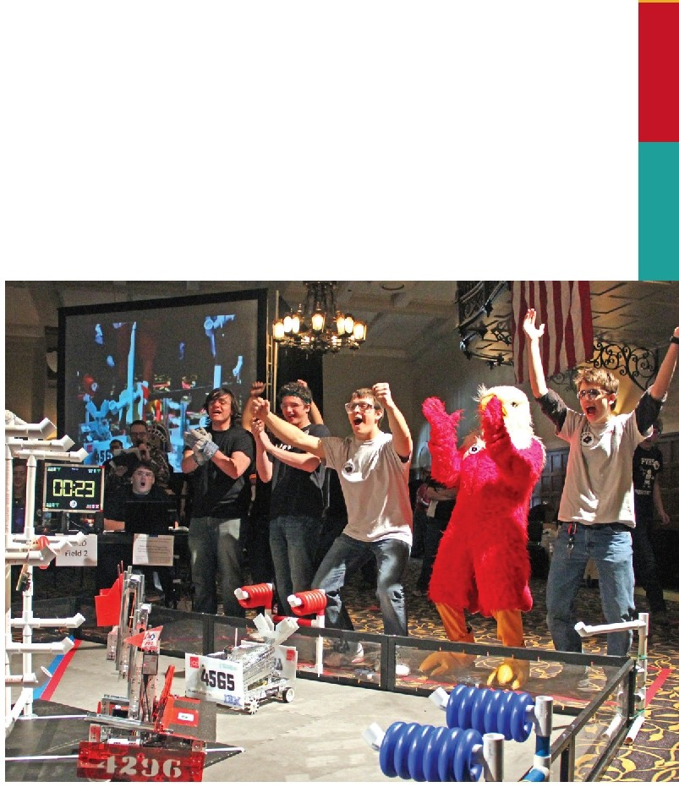Make your request within the first few sentences. It's important to state your purpose early and clearly.
  + It's recommended that you suggest a sponsorship level in the cover letter (See the donor acknowledgement card for more information). If it makes sense, don't be afraid to ask for the top sponsor level and/or funding for multiple years. If it's too much for the donor, they will likely come back to you with a lesser amount.
  + Request a meeting so your team can present more information about FTC and the benefits of sponsorship.
* Sponsor information on *FIRST* Tech Challenge
  + Be sure to include the page in the appendix about the benefits of an FTC sponsorship.
* Donor Acknowledgement Card
  + Determine who on your team will be the contact person along with the Coach. Typically, it's the person with the personal relationship with the potential donor.

Present the Sponsorship Packet

Once you've created your packet, it's typically best to print the materials and present it in person. If there's a connection with a friend or a family member, you also can ask them to present the packet.

Prepare for your meeting

* Determine who the spokesperson will be when meeting with the decision maker. It could be one or multiple team members. Keep in mind that it's typically best if the students make the ask.
* Develop an elevator speech. In 60 seconds, who are you, what are you doing, what is your goal and how can a sponsorship help?
* Consider creating and showing a short video of your team's work.

Meet with the decision maker

Consider taking your robot to help explain the program and let the decision maker drive it! The spokesperson should tell the decision maker:

* Why they're excited about FTC.
* Their 60-second elevator speech. (Who you are, what you're doing, what is your goal, and how a sponsorship can help.)
* Explain how a sponsorship level will specifically help the team.
* Indicate ways the team will help promote the sponsorship. (Logo on team t-shirts, etc.)
* If the business or organization is unable to commit to a sponsorship this year, it is recommended that students ask the decision maker if he/she would like to buy light bulbs to help support the team.

Follow up

If you receive a yes, it's important to immediately send a thank you note. A template to help you write the thank you note is available in the appendix. You may also want to send a team photo with your thank you note.

If you don't immediately receive a response, one of your team members should follow up with a phone call about one week later to inquire about the decision. Continue to follow up until you receive a decision. Remember, most Sponsors make donations because they are personally asked.



**Appendix**

**Fundraising Resources**

* <http://www.usfirst.org/roboticsprograms/first-fundraising-toolkit> 🡪 *FIRST* fundraising toolkit
* <http://www.firstnemo.org> – Non-Engineer Mentor Organization
* <http://www.usfirst.org/roboticsprograms/first-green-e-watt-saver> 🡪 *FIRST* green ewatt saver site
* <http://www.youtube.com/watch?v=8nnYPpOya84&feature=c4-overview&list=UUkWMXdRQr5yoZRz7gFYyRcw> 🡪 FTC Fundraising Hangout on Air
* <http://www.youtube.com/watch?v=5jln45FMoNI> 🡪 What is FTC video
* <http://www.usfirst.org/roboticsprograms/team-grants-faq> 🡪 Team Grants FAQ
* [ftcgrants@usfirst.org](mailto:ftcgrants@usfirst.org) 🡪 Grants questions and applications e-mail
* <http://www.usfirst.org/regional-contacts> 🡪 how to find an affiliate partner
* <http://www.usfirst.org/roboticsprograms/ftc/budget> 🡪 FTC team cost break down
* <http://www.donorschoose.org/> 🡪Donors Choose - several teams have received funding through this organization
* <http://www.kickstarter.com/> 🡪 Funding organization
* <http://www.usfirst.org/roboticsprograms/marketing-tools/ftc/2011-photo-gallery> 🡪 Promotional photos
* <http://www.usfirst.org/roboticsprograms/marketing-tools/brand?id=17122> 🡪 FIRST and FTC logos
* <http://www.usfirst.org/sites/default/files/uploadedFiles/Robotics_Programs/FTC/FTC_Documents/FTC-2013-Presentation.pptx> 🡪 FTC Power Point Presentation
* <http://ftcforum.usfirst.org/forum.php> 🡪 FTC forum
* <https://www.facebook.com/FTCTeams> 🡪 FTC Facebook
* <http://www.youtube.com/firsttechchallenge> 🡪 FTC YouTube Channel
* <https://twitter.com/ftcteams> 🡪 FTC Twitter
* <http://firsttechchallenge.blogspot.com/> 🡪 FTC Blog

**Sample Fundraising Letter**

Enter School/organization name

Enter Address

Enter city, state and zip

(or use pre-made letterhead from your school or organization)

Date:

Dear Xxxxx,

I am a participant in the *FIRST®* Tech Challenge (FTC®) program from (Enter your school or organization).

FTC is an out-of-school program for students, grades 7-12, to learn about the fields of science, technology, engineering, and math (STEM) through hands-on learning of the field of robotics. I am writing to you in hope of seeking team funding.

Through the FTC program, my robotics team members build and program robots. These robots then compete at regional competitions, with the potential of qualifying for the FTC (insert your state) State tournament and the World Championship competition. (Enter details about number of students on the team. Include information about your Coach and Mentors).

Participating in FTC allows me and my team members to learn more about math and science, while expanding my knowledge of careers involving computer programming, business, and engineering. As you may know, getting young people interested in these fields is very important, not only to our community, but also to our state and country.

Since this program is volunteer based, community support is important. Our team would like to set up a time with you to explain why we are so excited about FTC. We’d also like to share with you the benefits of becoming (Enter suggested sponsorship level) and other ways to support FTC.

More information about our program can be found at (URL of website, if available). Additional information about the *FIRST* Tech Challenge program can be found at [www.usfirst.org/ftc.](http://www.usfirst.org/ftc)

In the next few days, my Coach, (Enter name of Coach), will be calling to set up a meeting. You also can contact (him/her) at (phone) or send an e-mail to (e-mail).

Sincerely,

Name

FTC Team #

E-mail address

Names of Coaches and Members

**Donor Acknowledgement Card**

A *FIRST®* Tech Challenge (FTC®) team is successful because of partnerships with local businesses, foundations, and individuals.

|  |  |
| --- | --- |
| **Sponsor Level** | **This amount will help to support the following:** |
| $15 | General team support |
| $15.01-$49.00  Individual Donor | Helps teams to purchase tools to use over many seasons. |
| $50-$249  Supporting Sponsor | Teams are able to purchase a wireless connection module – which is required for FTC competition.  Funds can also be used to cover the registration fee for one tournament. |
| $250 - $499  Silver Sponsor | Teams are able to pay for the *FIRST* Registration fee.  Teams are able to pay the registration fee for two tournaments  (Plus all of the above) |
| $500-$999  Gold Sponsor | Teams are able to travel to tournaments out of town.  Teams are able to purchase challenge specific equipment for practice. (Plus all of the above) |
| $1,000 +  Platinum Sponsor | Teams are able to purchase robot equipment (extra motors, sensors, etc.).  If teams advance to the FTC World Championship, this will help with expenses.  (Plus all of the above) |

For informational purposes, the good news of your support will be shared with ______ FTC. Any individual, business or foundation that would like to contribute to the FTC-______ statewide initiative, please contact (name and e-mail)

Thank you for your contribution of $ on .

Your financial support will help our *FIRST* Tech Challenge team bring learning to life.

Organization:

FEIN #:

Contact person: ________________________________________________________________________

**Sample Thank You Letter**

Enter school/organization name

Address

City, State, Zip

(You may also choose to use pre-made letterhead from your school/organization)

Date:

Dear Xxxxx,

On behalf of the (your team’s name), the (organization/school)’s *FIRST*® Tech Challenge (FTC) Team, I’d like to thank you for your support to our team.

Your financial contribution of (amount), received on (date) will help us pay for items like robot parts and tools, and help us with tournament entrance fees, transportation, and lodging costs as we compete in the *FIRST* Tech Challenge program.

NOTE: If a sponsor gave funding that qualified for special recognition (i.e. company logo on a t-shirt), make sure you recognize it in the letter here.

I invite you to visit (team website, Facebook page, etc.) throughout the year to see photos and learn more about our team’s progress.

Sincerely,

Name

FTC Team #

e-maill address

Names of Coaches and Members

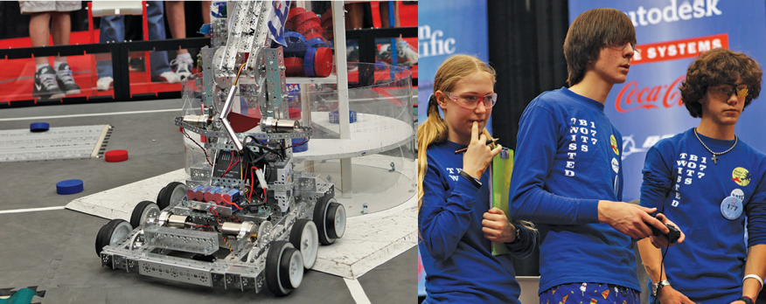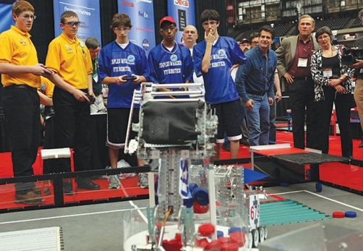



The *FIRST®* Tech Challenge: SPONSORS

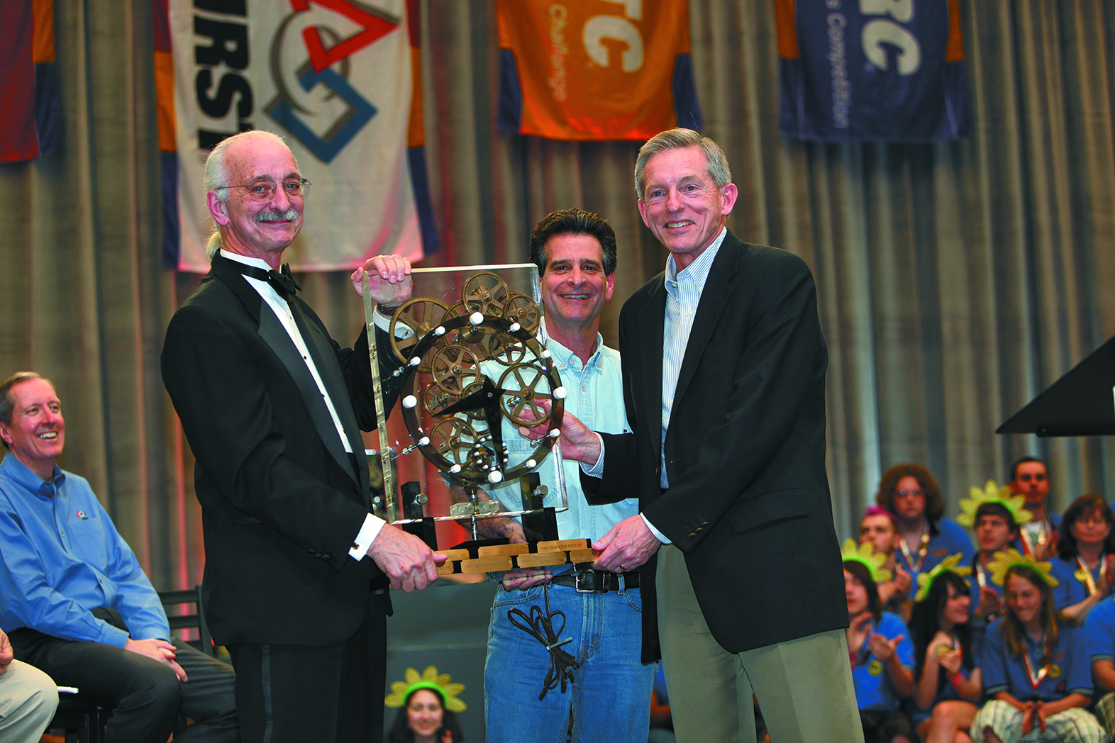

*“When you excite students with hands-on experiences and reinforce classroom learning with creative applications of content from textbooks, kids get motivated and want to learn. We’re proud to be*

*a part of FTC, so that these opportunities can be made accessible to students, schools, and*

*organizations that might not otherwise have the ability to participate.”*

Clay Jones Chairman and CEO Rockwell Collins

*“FTC is not just about robots. It's about inspiring and developing the next generation of engineers*

*and innovators."*

Rebecca Whitaker

Regional Manager

SE Iowa STEM Region

University of Iowa

It takes a strong network of local and state-wide supporters who provide funding, mentorship, time and talent, Volunteers, equipment, and more to make *FIRST®* Tech Challenge (FTC®) a reality in ____. FTC currently enjoys

support from a wide range of Sponsors including corporations, colleges and universities, community groups, museums, industry associations, and non-profit organizations.

Yet, we need your help in order to ensure FTC is available to every ____ student who dreams of developing the next generation of technological wonders.

Will your company, your organization, your circle of influence, your personal actions be the next to help future science and technology leaders in ______?

FTC teams develop strategy, build robots using a reusable, modular kit of parts, and compete head to head. Students learn to think like engineers.

Students get To:

■ Design, prototype, test, and compete using real-world practices (e.g. Engineering Notebooks, CAD software, and rapid prototyping)

■ Get hands-on programming and rapid-prototyping experience

■ Develop strategic-thinking, problem-solving, organizational, and team-building skills



Become an FTC Sponsor

■ Provide financial support to teams and events

■ Provide equipment, facilities, and/or training

■ Involve employees as Mentors, Coaches, and/or Volunteers

■ Help host a tournament for your community

Benefits of an FTC Sponsorship

■ Develops local talent to better position ______’s young people and the state’s economy for the future

■ Strengthens company reputation in the community

■ Increases employee volunteerism



Get Involved!

Join or start a team in your area

■

Sponsor a team, event, or local *FIRST* program

■

Become a team Mentor or Coach

■

Volunteer to fill over 100 roles

Check out our website:

or email:

*FIRST,® the FIRST® logo, FIRST® Robotics Competition, FRC,® FIRST® Tech Challenge, and FTC® are registered trademarks of the United States Foundation for Inspiration and Recognition of Science and Technology (FIRST).*

*© 2013 FIRST. All rights reserved. Last updated: 2/2013*